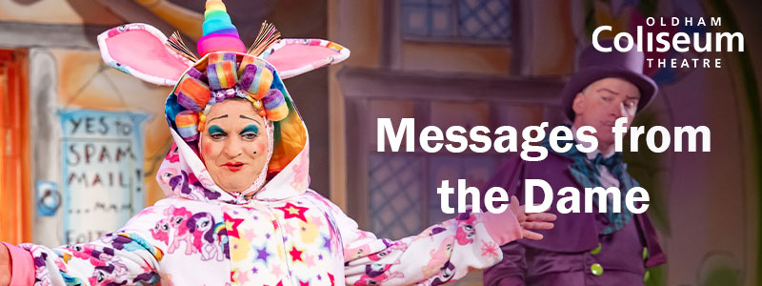
Complete this form to request a message from Dame Dotty Trott.

Who would you like to nominate for a message from the Dame?

Why are you nominating this person(s)

Tell us what great things they have done or challenges they’ve overcome.

How do you know your nominee?

Examples include: colleagues, neighbours, school teachers.

Is there anything you would like included in their message?

How would you like to send the nominee their message?

Messages can either be sent to you to share with the nominee or be sent directly to the nominee from the Coliseum.
In either case the message will be a video that is accessible via a link.

If you would like the Coliseum to send the message to the nominee, is there a specific date that would you like this to happen?

The Coliseum will strive to meet this date, subject to availability. Videos cannot be shared before the week of 7 December.

Are you happy for the video message from the Dame to be shared on the Coliseum’s Social Media channels?  If you agree, we will share the video message from the Dame on the Coliseum’s Facebook, Instagram and Twitter feeds so that our followers can also find out about the great things the person(s) you’re nominating have done.  Please delete as appropriate. | Yes | No
If you are happy for the Coliseum to share the video message on Social Media, please indicate from which date.

Example: If you are planning on sending your nominee their message on Christmas Day, please let us know not to share the message until after Boxing Day.

Your name.

Your email address.

Your nominee’s email address.

Deadline for submissions Wednesday 2 December 2020.
Please return this form via email to marketing@coliseum.org.uk

There are 20 video Messages from the Dame available and recipients will be selected by the Coliseum team. You will be contacted for any further details if your nominee is selected to receive a video.

