‘Set the Scene’ Photo Activity
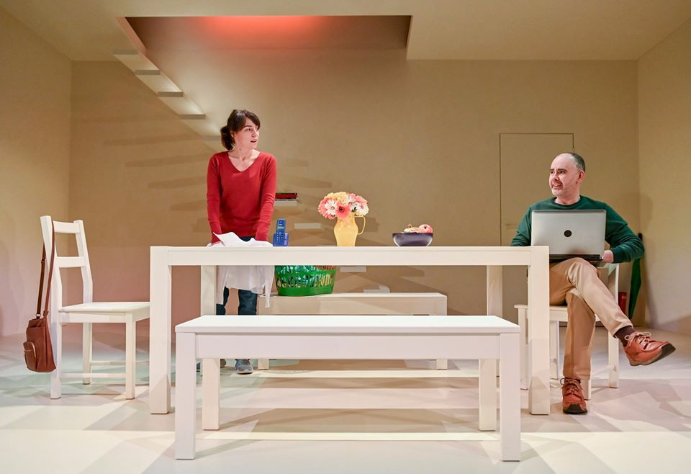
We recommend this activity to be suitable for people of all ages. Get involved!
During the past few months we have all spent much more time at home to socially distance ourselves from others. Whilst clearing out old cupboards or hoovering every square inch of your house, we have become more and more familiar with the hidden nooks and crannies of our homes.
But what if one area of your house was the setting for a play?
For our photo challenge we would like you to take a photograph of a space within your home that could be the entire set for a play. Make sure you have a character inhabiting the space. It could be someone in a small cupboard under the stairs or simply a character looking out of the window. How can it look like a theatrical set?
This is fun for all the family, so do get your adults involved and see how fun and creative you can make it!
Once you have your photo, we would like you to caption the picture with an opening line from this imaginary play. Try and make this line relate to the image we are seeing and give cause for an audience to want to see more.

Example:
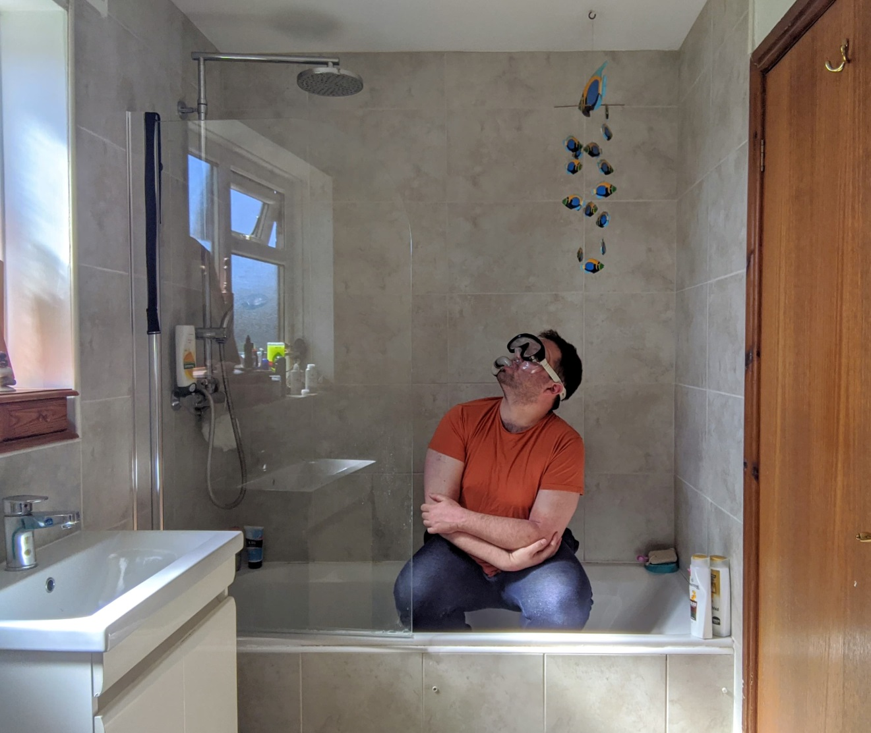
Here is an example from our Learning and Engagement Officer Ben.
Opening Line: “I think there’s a good chance I might get wet…”

Guidelines:
- If you are under 18, do make sure you get written permission from an adult before sending us your photo.
- Don’t take a photo of your bedroom, it’s best to have the pictures showing bright communal areas!
- Make sure your photo doesn’t give any hints to where you might live. This may be if you have any unique front doors or remarkable landmarks nearby.
- Try and make your play’s opening line interesting or funny, it should aid the picture’s overall effectiveness.

We would love to see your amazing photos and creations! If you would like to share what you have created, remember you can use the hashtag #ColiseumCreates on all social media sites. Do remember you must get your parent/guardian's written permission if you are under the age of 18.

