Thank you for your interest in the post of Marketing Officer

You will find enclosed the following information:
- Application pack;
- Application form and equal opportunities monitoring form;
- Current season brochure.

Please send the completed application form by email to: recruitment@coliseum.org.uk
Or by post to: Recruitment,
Oldham Coliseum Theatre,
Fairbottom Street,
Oldham, OL1 3SW

The closing date is: 9am, Monday 20 January 2020
Interviews will be held: week commencing Monday 27 January 2020

Please note: We don’t accept CVs. Only applications made on the Coliseum application form will be considered for this role.

Oldham Coliseum Theatre is an equal opportunities employer, dedicated to providing an inclusive and accessible experience for everyone who engages with the theatre. We are Disability Confident Committed. We encourage applications from people of all backgrounds in order to reflect the diversity of our work and communities. All appointments will be made on merit.

If you would like to discuss any of this information, request a printed version, large print or dyslexia friendly application pack, please don’t hesitate to get in touch on: 0161 624 1731 or recruitment@coliseum.org.uk

Best wishes,

Laura Rodwell
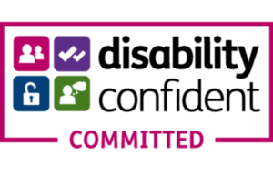
Head of Marketing

