Coliseum Colour-in
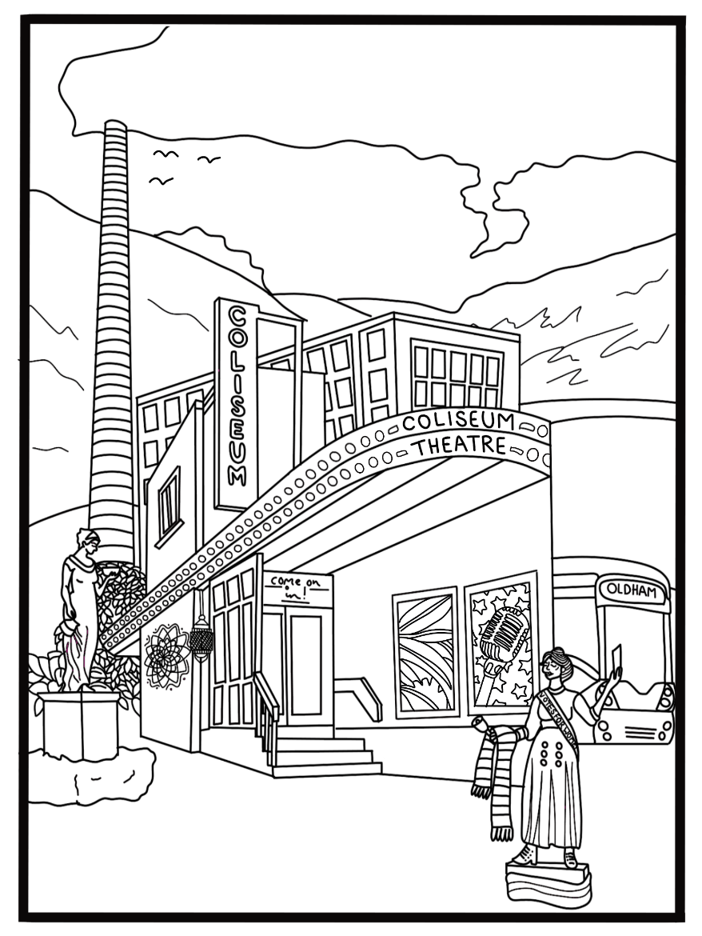
We recommend this activity is suitable for children aged 10 and under.
What can you see…?

Take a look at the below picture of the Coliseum.

What famous Oldham landmarks do you recognise surrounding our theatre?
Are there any more Oldham landmarks you could add into the picture yourself?

Have a go at colouring-in your very own version of the Coliseum at home!

Illustration by Rose Sergent
We would love to see your own version of the Coliseum! If you would like to share what you have created, remember you can use the hashtag #ColiseumCreates on all social media sites. Do remember you must get your parent/guardian's written permission if you are under the age of 18.
