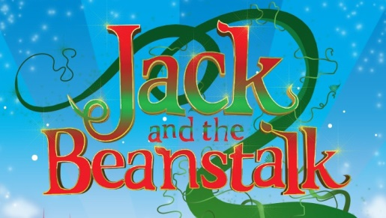
Chorus Auditions Registration Form
Auditions will take place at Oldham Coliseum on Sunday 01 September. Audition times will be allocated based on age.
Child’s name
Age
Gender

Address
School
Parent/Guardian’s name
Mobile number
Home number
Email address
Please return this form by email to Rachel or Rose: casting@coliseum.org.uk or by post to Oldham Coliseum Theatre, Fairbottom Street, Oldham, OL1 3SW
If you have any questions, please contact us on the email above or on 0161 624 1731.

