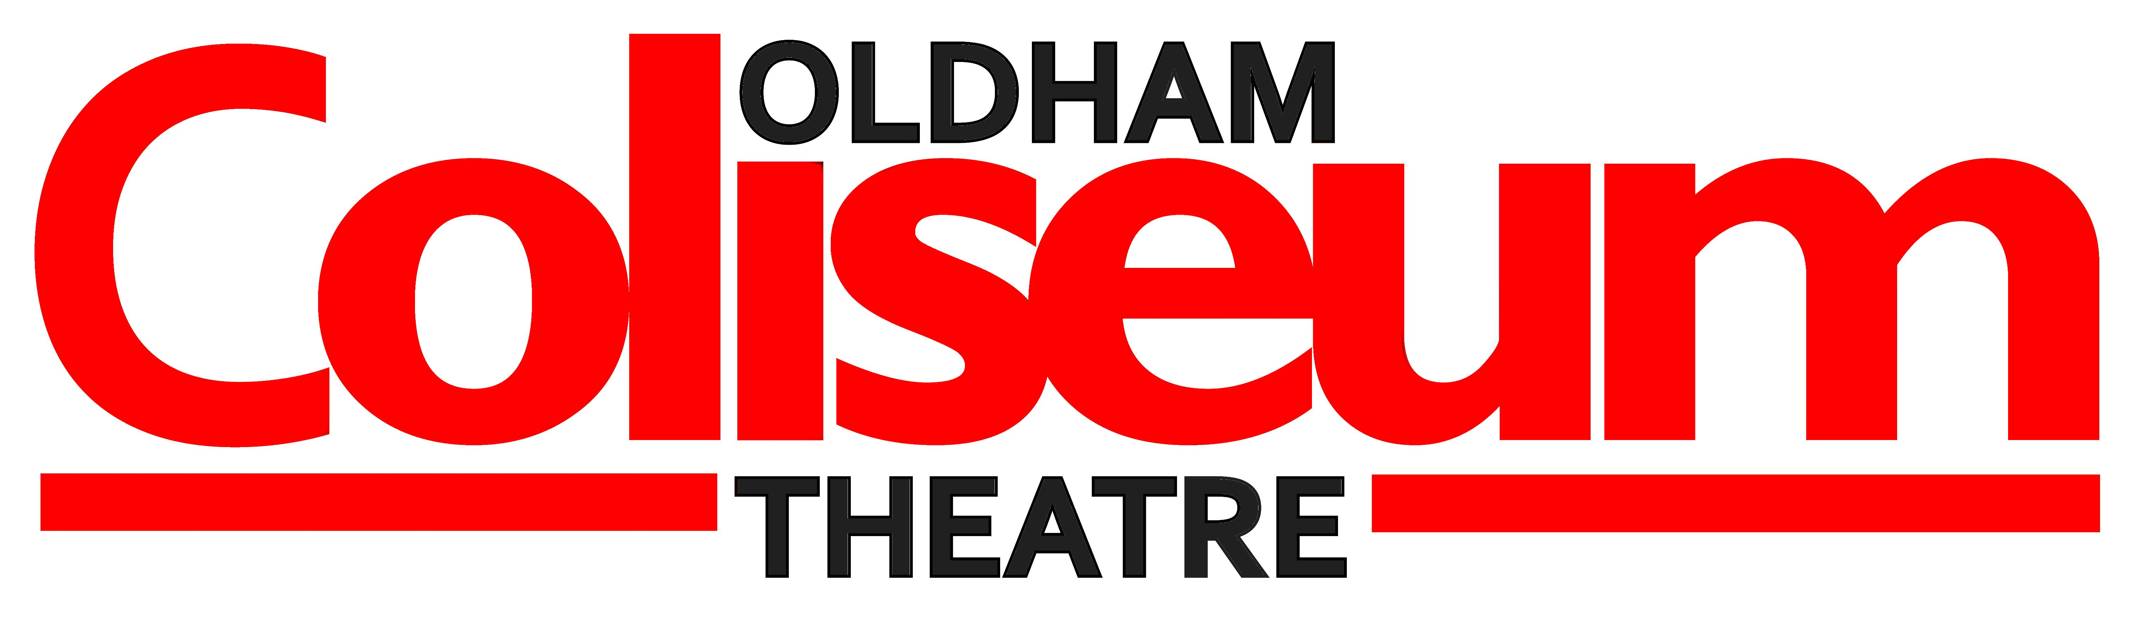

The Picture of Doreen Gray Choir

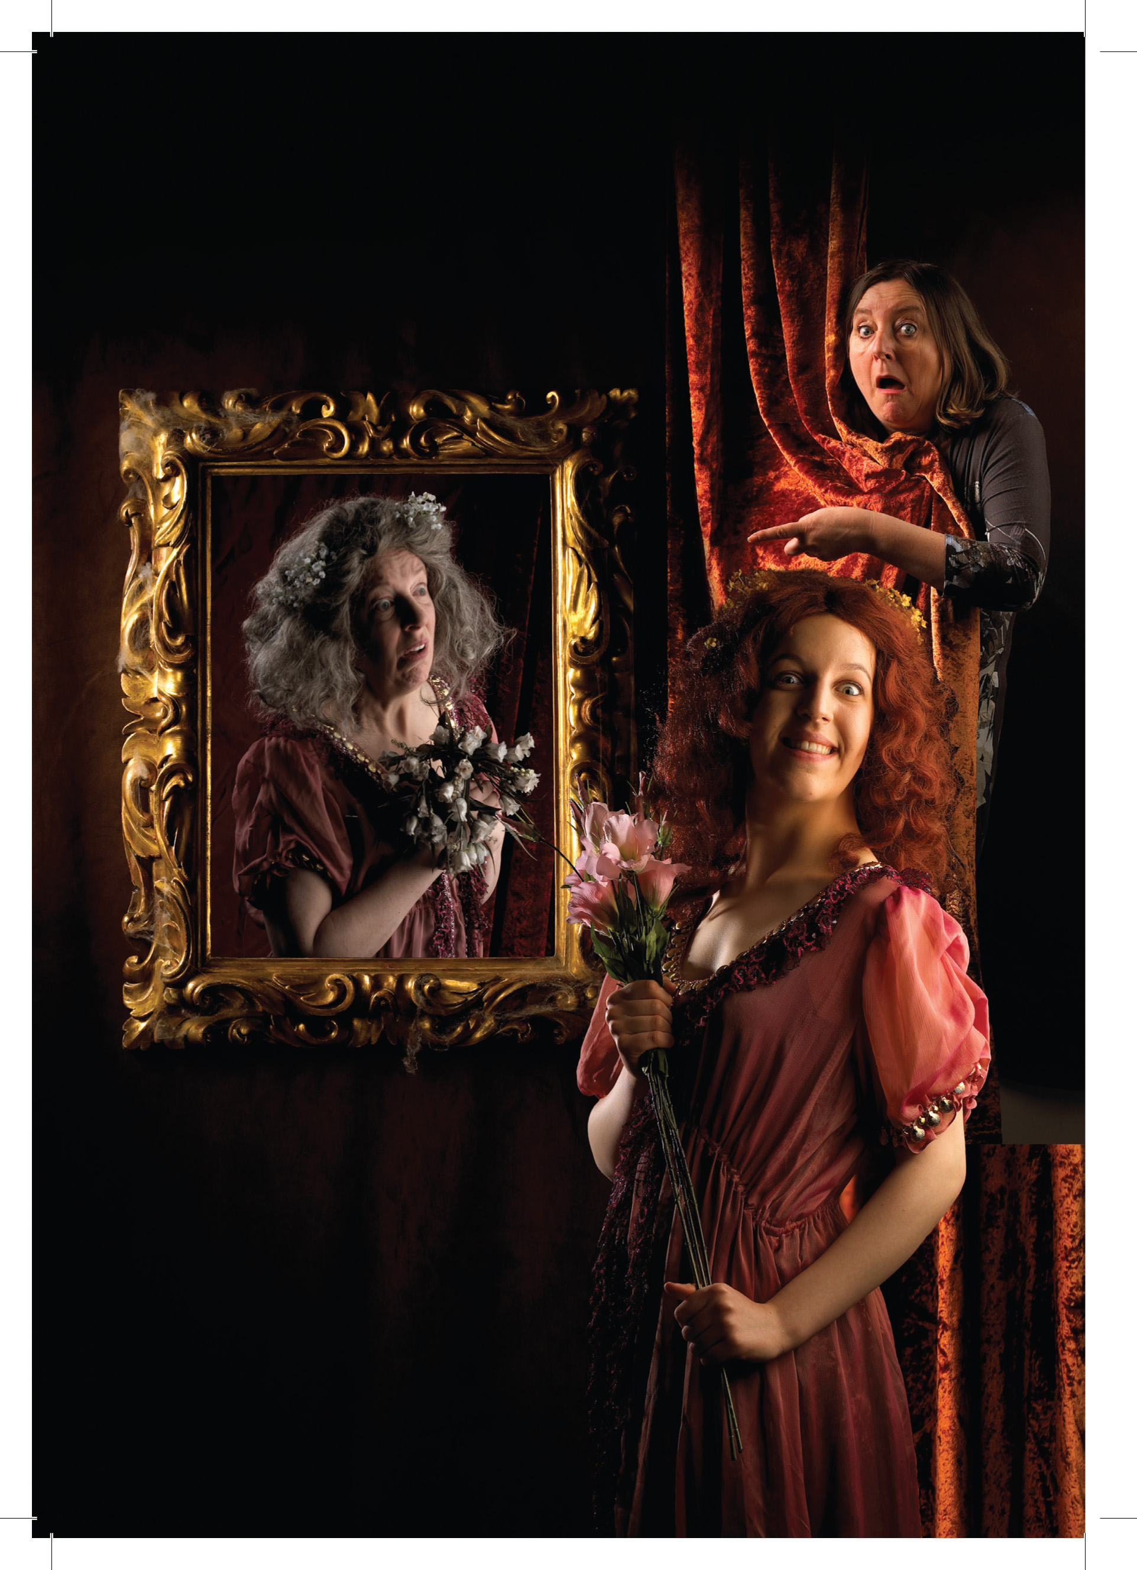
Thursday 16 October to
Saturday 25 October 2014
Following the enormous success of Desperate to be Doris here at the Coliseum, Lip Service Theatre Co and Oldham Coliseum Theatre are again recruiting for a strong community choir to take part in the premiere of their hilarious production of The Picture of Doreen Gray at the Coliseum Theatre in October.

Peter Wakefield will again be our choral director for this production.

Name: …………………………………………………………..
Gender: ...…… Age:.………… (Over 18 only)
Contact Number:………………………………………...…
E mail: ………….……………………………………………….
Address: ……………..…………..............................................
.........................................................................................................................................

Voice Type: (please circle) Soprano Alto Tenor Bass Unsure

Do you currently perform in a choir? If so which?..............................................................

Were you in the Desperate to be Doris choir either at Oldham or another venue?
YES / NO

We might not have room for everyone so we may have two choirs and split the performance schedule. We will confirm your acceptance into the production by the beginning of September subject to numbers and mix of voice types/age/sex.

Choir Rehearsals:
Will probably be Tuesday evenings (tbc) with additional rehearsals during the production week (w/c 13 October 2014)

Performance Times: (we may split these performances between two groups – more details later)
Thursday 16 to Saturday 25 October @ 7.30pm with matinees on Wednesday 22nd and Saturday 25 @ 2.30pm)
You will need to be at the Coliseum 35 minutes before a performance begins

It would be helpful if you could attach a recent photograph.

Please return to: Nicola Place, Coliseum Theatre, Fairbottom Street, Oldham, OL1 3SW
nicolaplace@coliseum.org.uk

